System/Software Requirements Specification

for

Share Food

**Version 0.1 Beta**

**Prepared by Phạm Hồng Sơn**

**Phùng Thị Lan**

**FPT University**

**November, 13, 2020**

**Table of Contents**

**Table of Contents**

**Revision History**

**1.** **Introduction**

1.1 Purpose

1.2 System Purpose

1.3 Definitions, Acronyms and Abbreviations

1.4 Document Conventions

1.5 Intended Audience and Reading Suggestions

1.6 References

**2.** **Overall Description**

2.1 Product/System Perspective

2.2 System/Product Features

2.3 User requirements

2.4 User Classes and Characteristics

2.5 Operating Environment

2.6 Design and Implementation Constraints

2.7 User Documentation

2.8 Apportioning of Requirements

**3.** **Specific Requirements**

3.1 Functional Requirements Specification

3.1.1 Function1 /Use-case 1

3.1.2 UC01-Login<Sample>

3.1.3 Function2 /Use-case 2

3.2 Non-Functional Requirements Specification

3.2.1 External Interface Requirements

3.2.2 Other Nonfunctional Requirements

**4.** **Other Requirements**

**Appendix A: Glossary**

**Appendix B: Analysis Models**

**Appendix C: Issues List**

**Revision History**

|  |  |  |  |
| --- | --- | --- | --- |
| **Name** | **Date** | **Reason For Changes** | **Version** |
|  |  |  |  |
|  |  |  |  |

# Introduction

## Purpose

Nowadays, the sharing of good eateries with friends is essential so a App for sharing is essential. The tool needs to be easy to use, soft, and most importantly it can be used anywhere. So a mobile application is a good idea for this.

## System Purpose

"ShareFood" is an Android application for mobile devices to share delicious restaurants, users have a list of restaurants, display restaurants within 10 km, search for restaurants, post food, and eateries. , allowing users to rate and comment on photos and videos of food and restaurants

## Definitions, Acronyms, and Abbreviations

|  |  |
| --- | --- |
| **Acronym** | **Definition** |
| **SF** | ShareFood |
| **DBMS** | Database Management System |
| **GUI** | Graphical User Interface |
| **HTTP** | Hypertext Transfer Protocol |
| **HTTPS** | Hypertext Transfer Protocol Secure |
| **IDE** | Integrated Development Environment |
| **N/A** | Not Available |
| **OS** | Operating System |
| **UC** | Use Case |
| **UI** | User Interface |
| **UML** | Unified Modeling Language |
| **URL** | Uniform Resource Locator |
| **UX** | User Experience |

## Document Conventions

* Font family: sans-serif, cursive.
* Font weight: Regular.
* Font size: 11.
* Font weight heading 1: bold.
* Font size heading 1: 18.
* Font weight heading 2: bold.
* Font size heading 2: 14.

## Project Scope

This app is for everyone who has an Android smartphone when you need help. Application for you to share food, delicious eateries with friends. This application is suitable for everyone

## References

## Software requirement specification form

## SRS of Cafeteria Ordering System (by Karl Wiegers)

## Software engineering – Ninth Edition (by Ian Sommerville)

# Overall Description

## Product/System Perspective

This ultimate software product is for everyone who wants a tool to share a restaurant, a good tool.

The product will release a free, open source product application. Users can easily view the Application with a smartphone

## System/Product Features

The application can run on smartphones using Android operating system, android 8.1 / API27 above

Users can view list of restaurants, display restaurants within 10 km, search for restaurants, post food, and eateries. , allowing users to rate and comment on photos and videos of food and restaurants

## User Classes and Characteristics

|  |  |
| --- | --- |
| **Object** | **Description** |
| User |  |

Open application for everyone

Characteristics: Software doesn’t require any special characteristics of the user. Every user can become a member of the system.

## Operating Environment

## Distributed database

* Operating System: Android System
* Database: Realtime Database, Storage Firebase.
* Platform: Android
* Library: N/A

## Design and Implementation Constraints

Developers should also be careful about the privacy of users.

The Internet connection is a constraint for the application. Since the application fetches data from the database over the Internet, it is crucial that there is an Internet connection for the application to function.

## Assumptions and Dependencies

Assump users have an android smartphone >=A.ver 8.1, API 27, and the user also have knowledge about using it at the minimum level (access, fill in the field).

## Apportioning of Requirements

# Specific Requirements

## Functional Requirements Specification

**Business Rules**

|  |  |
| --- | --- |
| **ID** | **Descriptions** |
| B01 | User needs using the App Store to download the app. |

Use case Diagram

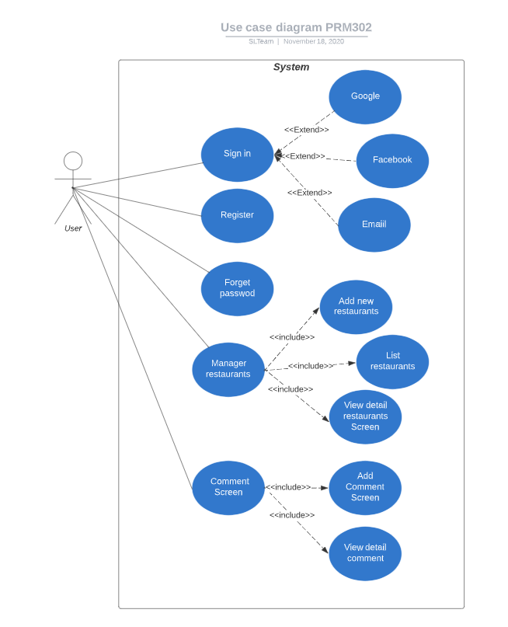 <https://lucid.app/invitations/accept/5b2d6085-664d-4260-958f-a67504aaec29>

**Architecture system**

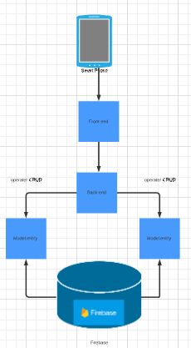

<https://lucid.app/invitations/accept/f8d7a36d-c9e7-4fd8-bc53-f9a125b4a91c>

**Link github:** [**https://github.com/zeno4499/ShareFoody.git**](https://github.com/zeno4499/ShareFoody.git)

|  |  |  |
| --- | --- | --- |
| **ID** | **Actor** | **Name** |
| UC01 | User | Login |
| UC02 | User | Register |
| UC03 | User | Forget Password |
| UC04 | User | List of restaurants Screen |
| UC05 | User | View detail restaurants Screen |
| UC06 | User | Add new restaurants Screen |
| UC07 | User | Add Comment Screen |
| UC08 | User | View detail comment |

### Function1 /Use-case 1

3.1.1.1 Design Home Screen

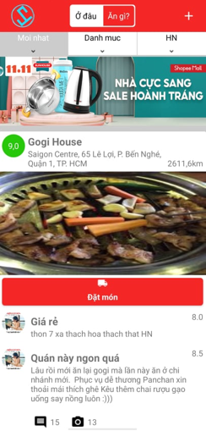

SCR-01: Home screen

### UC01 – Login Screen

#### Login Screen Design

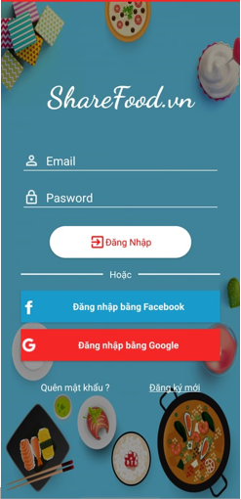

SCR-02: List Restaurant Screen

**Table 3-1: Screen Definition**

|  |  |  |  |  |  |
| --- | --- | --- | --- | --- | --- |
| **#** | **Field Name** | **Type** | **Mandatory** | **Max Length** | **Description** |
| 1 | Logo | Text | No |  |  |
| 2 | Email | Input | No |  |  |
| 3 | Password | Input | No |  | Display "*" instead of clear character |
| 4 | DangNhap | Button | No |  | Sign in with email and Go to home App |
| 5 | LoginGG | Button | No |  | Sign in with Google and Go to home App |
| 6 | ForgetPassword | Text | No |  | Forget Password |
| 7 | Register | Text |  |  | Click login then redirect to Register Screen |

**Figure 3-1**: Screen Design of Register

#### Use Case Specification

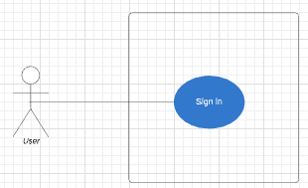

**Figure 3-2:** Register Use-Case Diagram

|  |  |
| --- | --- |
| **Use Case ID** | **UC-01** |
| **Use Name** | **List Restaurant** |
| **Actor** | User |
| **Description** | List restaurant |
| **Precondition** |  |
| **Trigger** |  |
| **Post-Condition** |  |
| **Normal Flow** | **1.0 Login**   1. Guest open App 2. System display Slash Screen after redirect to Login Screen 3. System display Login Screen App home page. 4. Guest enters email, password on the registration form. 5. Guest clicks “Đăng nhập”button on the Login Screen. 6. System move to Home App |
| **Alternative flows** | N/A |
| **Exceptions** |  |
| **Priority** | Medium |
| **Frequency of Use** | Medium |
| **Business Rules** | B01 |
| **Other Information** | N/A |
| **Assumptions** | N/A |

### UC02 - Register Screen

#### Screen Design

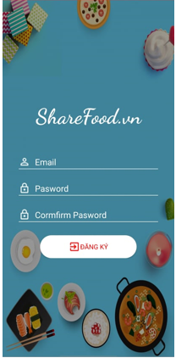

**SRC-03**: Screen design of ShareFood

**Table 3-1: Screen Definition**

|  |  |  |  |  |  |
| --- | --- | --- | --- | --- | --- |
| **#** | **Field Name** | **Type** | **Mandatory** | **Max Length** | **Description** |
| **1** | **ShareFood** | **Text** | **No** |  | **Logo app** |
| 2 | Email | Input | No |  |  |
| 3 | Password | Input | No |  |  |
| 4 | Confirm Password | Input | No |  |  |
| 5 | Đăng ký | Button | No |  | Resgister |

#### Use Case Register

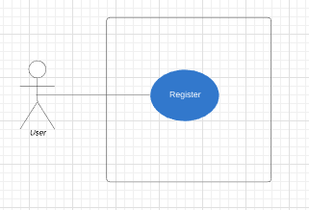

**Figure 3-14:** Register Use-Case Diagram

|  |  |
| --- | --- |
| **Use Case ID** | **UC-02** |
| **Use Name** | **Register** |
| **Actor** | User |
| **Description** | Screen Show register new account |
| **Precondition** | N/A |
| **Trigger** | N/A |
| **Post-Condition** | N/A |
| **Normal Flow** | 1. **Register**   1.Guest open App  2.System display ShareFood App home page.  3.Guest clicks  Register  4.System displays login/register  5.Guest enters email, password, Cormfirm password on the registration form.  6. Guest clicks “Đăng ký”button on the registration form.  7. System move to Home App |
| **Alternative flows** | N/A |
| **Exceptions** | N/A |
| **Priority** | Medium |
| **Frequency of Use** | Medium |
| **Business Rules** | B01 |
| **Other Information** | N/A |
| **Assumptions** | N/A |

### UC03 – Forget Password

#### Screen Design

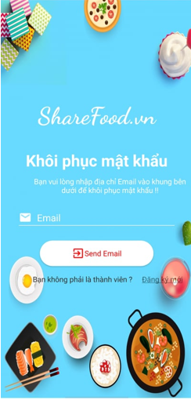

**SRC-04**: Screen Design of Forget Password

**Table 3-1: Screen Definition**

|  |  |  |  |  |  |
| --- | --- | --- | --- | --- | --- |
| **#** | **Field Name** | **Type** | **Mandatory** | **Max Length** | **Description** |
| 1 | ShareFood.vn | Text | No |  | Logo app |
| 2 | Email | Input | No |  |  |
| 3 | SendEmail | Button | No |  | System send link reset password to email |

#### Use Case Specification

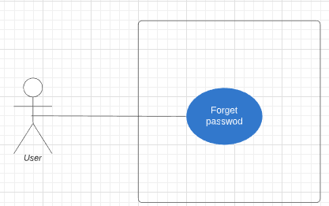

**Figure 3-16:** Forget password Use-Case Diagram

|  |  |
| --- | --- |
| **Use Case ID** | **UC-3** |
| **Use Name** | **Forget Password** |
| **Actor** | User |
| **Description** | Enter email and send new password to that email |
| **Precondition** | N/A |
| **Trigger** | N/A |
| **Post-Condition** | **N/A** |
| **Normal Flow** | 1.Guest open App  2.System display ShareFood App home page.  3.Guest clicks  Forget Password  4.System displays Forget Password Screen  5.Guest enters email on the registration form.  6. Guest clicks “Send Email”button  7. System send link reset password to email  8. Guest go to mail click to link and reset password  9. Back to login App  10.System display Login Screen App home page.  11.Guest enters email, password on the registration form.  12.Guest clicks “Đăng nhập”button on the Login Screen.  13.System move to Home App |
| **Alternative flows** | N/A |
| **Exceptions** | N/A |
| **Priority** | Medium |
| **Frequency of Use** | Medium |
| **Business Rules** | B01 |
| **Other Information** | N/A |
| **Assumptions** | N/A |

### UC04 - List Restaurent

#### Screen Design

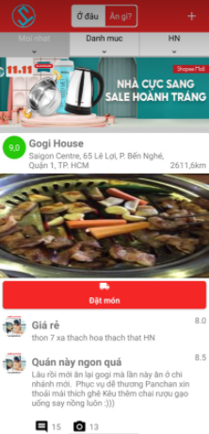

**SRC-05**: Screen Design of list restaurent

**Table 3-1: Screen Definition**

|  |  |  |  |  |  |
| --- | --- | --- | --- | --- | --- |
| **#** | **Field Name** | **Type** | **Mandatory** | **Max Length** | **Description** |
| 1 | Back | Button | No |  | Back to Home screen |

#### Use Case Specification

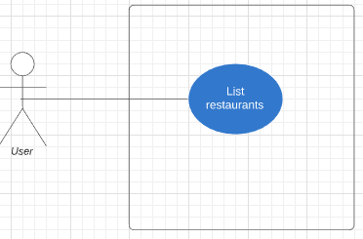

**Figure 3-22:** List restaurent Use-Case Diagram

|  |  |
| --- | --- |
| **Use Case ID** | **UC-04** |
| **Use Name** | List Restaurent |
| **Actor** | User |
| **Description** | List restaurant about name, address, distance, image, comment of restaurant |
| **Precondition** | N/A |
| **Trigger** | N/A |
| **Post-Condition** | **N/A** |
| **Normal Flow** | **1.0 Go in Checklist**   1. User Open app 2. System display list restaurant Screen. 3. Guest scroll down to show more restaurant 4. The system displays navigate to Compass Screen |
| **Alternative flows** | N/A |
| **Exceptions** | N/A |
| **Priority** | Medium |
| **Frequency of Use** | Medium |
| **Business Rules** | B01 |
| **Other Information** | N/A |
| **Assumptions** | N/A |

### UC05 - View Detail Restaurants Screen

#### Screen Design

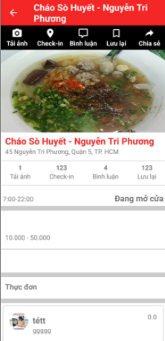

### SRC-06: View Detail Restaurants Screen

**Table 3-1: Screen Definition**

|  |  |  |  |  |  |
| --- | --- | --- | --- | --- | --- |
| **#** | **Field Name** | **Type** | **Mandatory** | **Max Length** | **Description** |
| 1 | Back | Button | No |  | Back to Home screen |
| 2 | Restaurant Title | Text | No |  |  |
| 3 | Comment | Text | No |  |  |
| 4 | Restaurant Name | Text | No |  |  |
| 5 | Restaurant Address | Text | No |  |  |
| 6 | Time Of Restaurant | Text |  |  |  |
| 7 | Price of Restaurant | Text |  |  |  |
| 8 | Service of Restaurant | List |  |  |  |
| 9 | Menu of restaurant | List |  |  |  |
| 10 | List Comment | List |  |  |  |

#### Use Case Specification

**Figure 3-24:** Currency Converter Use-Case Diagram

|  |  |
| --- | --- |
| **Use Case ID** | **UC-05** |
| **Use Name** | View Detail Restaurants Screen |
| **Actor** | User |
| **Description** | The function allows learn quiz with write. |
| **Precondition** | N/A |
| **Trigger** | N/A |
| **Post-Condition** | N/A |
| **Normal Flow** | **1.0 Go in Detail Restaurant**   1. User Open app 2. System display List Restaurant home Screen. (SCR-01) 3. User clicks the Item on Home screen. 4. The system displays navigate to Detail Restaurant Screen   **1.1 Back to Home**   1. press back button on header   **2.0 Add Comment**   1. press on Icon Bình Luận on Header 2. System navigate to Add Comment Screen   **2.1 Detail Comment**   1. press on image of Item Comment 2. System displays navigate to Detail Comment |
| **Alternative flows** | N/A |
| **Exceptions** |  |
| **Priority** | Medium |
| **Frequency of Use** | Medium |
| **Business Rules** | B01 |
| **Other Information** | N/A |
| **Assumptions** | N/A |

### UC06 - Add new restaurants Screen

#### Screen Design

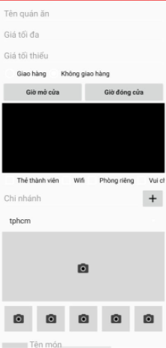

### SRC-07: Screen Add new restaurants Screen

**Table 3-1: Screen Definition**

|  |  |  |  |  |  |
| --- | --- | --- | --- | --- | --- |
| **#** | **Field Name** | **Type** | **Mandatory** | **Max Length** | **Description** |
| 1 | Restaurant Name | Input | No | 255 |  |
| 2 | Max Price | Button |  |  |  |
|  | Min Price |  |  |  |  |
|  | Ship |  |  |  |  |
|  | Not Ship |  |  |  |  |
|  | Open time |  |  |  |  |
|  | Close time |  |  |  |  |
|  | List Service |  |  |  |  |
|  | Branch |  |  |  |  |
|  | List Province | Spinner |  |  |  |
|  | Image |  |  |  |  |

#### Use Case Specification

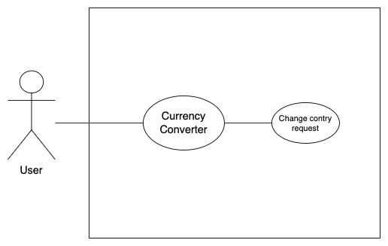

**Figure 3-26:** Add new restaurant Use-Case Diagram

|  |  |
| --- | --- |
| **Use Case ID** | **UC-06** |
| **Use Name** | **Add new restaurants** |
| **Actor** | User |
| **Description** | Add new restaurant |
| **Precondition** | N/A |
| **Trigger** | N/A |
| **Post-Condition** | N/A |
| **Normal Flow** | * In list restaurant screen , click “+” * Open the add new restaurant screen * Input fields : restaurant name , restaurant address , max price , min price , ship or not ship , open time , close time , list service,image * Click button save new restaurant |
| **Alternative flows** | N/A |
| **Exceptions** | N/A |
| **Priority** | Medium |
| **Frequency of Use** | Medium |
| **Business Rules** | B01 |
| **Other Information** | N/A |
| **Assumptions** | N/A |

### UC07 - Add Comment Screen

#### Screen Design



### SRC-07: Screen Add Comment

**Table 3-1: Screen Definition**

|  |  |  |  |  |  |
| --- | --- | --- | --- | --- | --- |
| **#** | **Field Name** | **Type** | **Mandatory** | **Max Length** | **Description** |
| 1 | Title | Input |  |  |  |
| 2 | Content | Input |  |  |  |
|  | image |  |  |  |  |
|  |  |  |  |  |  |

#### Use Case Specification



**Figure 3-26:** Add Comment Use-Case Diagram

|  |  |
| --- | --- |
| **Use Case ID** | **UC-06** |
| **Use Name** | **Add Comment** |
| **Actor** | User |
| **Description** | Add new Comment |
| **Precondition** | N/A |
| **Trigger** | N/A |
| **Post-Condition** | N/A |
| **Normal Flow** | * In list restaurant screen , click button comment * Open add comment screen * Input fiels : title (optional) , content , image * Click text view “đăng” |
| **Alternative flows** | N/A |
| **Exceptions** | N/A |
| **Priority** | Medium |
| **Frequency of Use** | Medium |
| **Business Rules** | B01 |
| **Other Information** | N/A |
| **Assumptions** | N/A |

### UC08 – View detail Comment

#### Screen Design



**SRC-05**: Screen Design of view detail comment

**Table 3-1: Screen Definition**

|  |  |  |  |  |  |
| --- | --- | --- | --- | --- | --- |
| **#** | **Field Name** | **Type** | **Mandatory** | **Max Length** | **Description** |
| 1 | Image user | Image |  |  |  |
|  | Title | Text |  |  |  |
|  | Content | Text |  |  |  |
|  | Image | Image |  |  |  |

#### Use Case Specification



**Figure 3-22:** View detail commentUse-Case Diagram

|  |  |
| --- | --- |
| **Use Case ID** | **UC-04** |
| **Use Name** | View detail comment |
| **Actor** | User |
| **Description** | View detail comment |
| **Precondition** | N/A |
| **Trigger** | N/A |
| **Post-Condition** | **N/A** |
| **Normal Flow** | * Click image and open view detail comment |
| **Alternative flows** | N/A |
| **Exceptions** | N/A |
| **Priority** | Medium |
| **Frequency of Use** | Medium |
| **Business Rules** | B01 |
| **Other Information** | N/A |
| **Assumptions** | N/A |

## 3.3 Non-Functional Requirements Specification

### 3.3.1 External Interface Requirements

#### 3.3.1.1 Hardware Interface

* Android >= ver 8.1/API 27 Environment
* Internet

#### 3.3.1.2 Software Interface

|  |  |  |
| --- | --- | --- |
| **ID** | **Software Used** | **Description** |
| 1 | OS | Android OS |
| 2 | XML | Build front-end |
| 3 | Java | Build backend |

### 3.3.2 Other Nonfunctional Requirements

#### 3.3.2.1 Safety Requirements

If there is extensive damage to a wide portion of the database due to catastrophic failure, such as a disk crash, the recovery method restores a past copy of the database that was backed up to archival storage (typically tape) and reconstructs a more current state by reapplying or redoing the operations of committed transactions from the backed up log, up to the time of failure.

#### 3.3.2.2 Performance Requirements

Any response must be within 2 seconds or less

After press any button, there’re always respond within 1 seconds (loading process, save success, etc)

**4. Other requirements**

**4.1 Internationalization requirements**

Because Vietnam is the most users from Viet Nam, so app version toward VietNamese is the prioritize. Furthermore, Sharing food helper app will useful with foreign tourists.